GOVERNMENT POLYTECHNIC
CHHAPRA
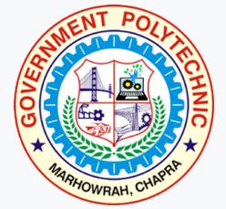
COURSE FILE (Lecture Plan)
OF
Basic Electrical & Electronics Lab (2033408)

Faculty Name:
Prof. SAURAV KUMAR
Lecturer

DEPARTMENT OF AUTOMOBILE ENGINEERING

STATE BOARD OF TECHNICAL EDUCATION
Bihar, Patna
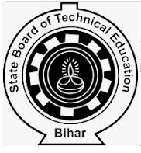
&
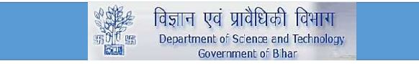

CONTENTS
1. Cover Page & Content

2. Vision of the Department

3. Mission of the department

4. Course Description & Course objectives

5. Course Syllabus

6. Reference Materials

7. Course outcomes (CO’s)

8. Time table

9. Student list

10. Lecture Plan

Department of Automobile Engineering

Vision
To be a centre of excellence in the field of Automobile Engineering offering value based world class education and research producing well qualified engineers, who can contribute favorably to the technological and socio-economic development of the nation.

Mission
1. To ensure sufficient modern technological exposure to the students in order to create skilled professionals.
2. To frequently update the labs keeping in view the requirement of the current industry scenario.
3. To extend counseling and career guidance facility to the students to help them to achieve their goal.
4. To encourage faculties and staffs to pursue higher education and to do the research work.
5. To encourage faculties and staffs to participate in various seminars, conferences and workshops to keep themselves updated of the state-of-the-art technology.

Course Description:-

It offers an unparalleled exposure to the entire gamut of topics such as Electricity Fundamentals, Network Theory, Electro-magnetism, Electrical Machines, Transformers, Measuring Instruments, Power Systems, Semiconductor Devices, Digital Electronics and Integrated Circuits. Extensive use of illustrations, examples and exercises in accordance with the progressive development of the concepts covered within the chapter make the reading more exciting. The course extensively includes number of illustrations, examples and exercises in accordance with the progressive development of the concept covered within the chapter to make the reading more exciting Features.

Course Objectives:-

The aim of this course is to help the students to attain the following industry identified competency through various teaching learning experiences:
Electricity Fundamentals, Network Theory, Electro-magnetism, Electrical Machines, Transformers, Measuring Instruments, Power Systems, Semiconductor Devices, Digital Electronics and Integrated Circuits

Course Syllabus
Subject Code | Practical |  |  |  |  |  | Credits
2033408 | No. of Periods Per Week |  |  | Full Marks | : | 50 | 02
 | L | T | P/S | ESE | : | 50
 | — | — | 04 | Internal | : | 15
 | — | — | — | External | : | 35
BASIC ELECTRICAL & ELECTRONICS LAB

CONTENTS: PRACTICAL

Skills to be developed:
Intellectual Skills:
- Select equipment such as motors, meters & components
- To interpret circuits
Motor Skills:
- To draw circuits
- To measure various parameters
List of Practical:
- For a given resistive & inductive series & parallel circuit, select ammeter, voltmeter & wattmeter. Make the connections and measure current, voltage and power drawn by the circuit. Measure it by clip on meter & compare it.
- For a given DC Shunt/Series motor, select suitable meters, make connections as per diagram, check the connections and run the motor. Take the meter readings to draw speed torque characteristics. Make suitable changes in the connections to reverse the direction of rotation.
- For the above given motor prepare a circuit to control its speed above & below normal, plot its graph.
- Testing of components like diode, LED, SCR, diac, triac, Zener diode, inductor, capacitor using a multimeter
- Verify truth tables for logic gates-. NOT, AND, OR, NAND, NOR.
- Calculation of Vdc of half and full wave rectifier with and without filter.
- Line & load regulation of alternator output using Zener diode.
- To measure shaft speed by using Stroboscope. Study and observe the characteristics of LVDT.

Course outcomes: A knowledge of the fundamentals of electronics and major functioning of electronic devices can assist a mechanical engineer to better communicate with electrical and electronics engineers collaborating for the design/manufacturing of these systems.

***************

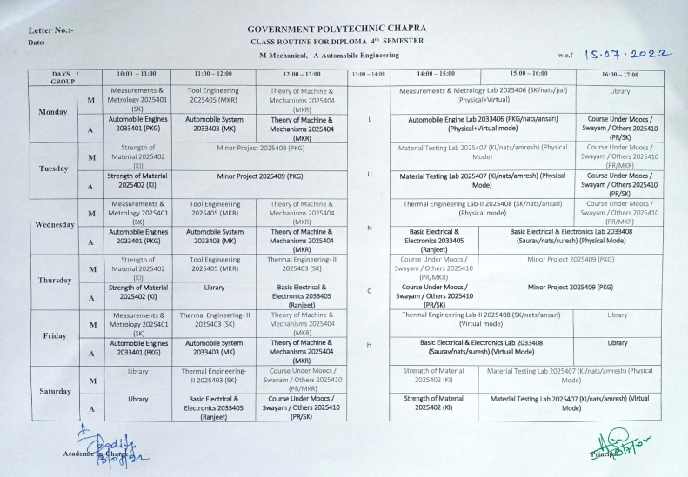

https://www.gpchhapra.org.in/2022/07/13/class-routine-notice/
TIME TABLE
FACULTY:- Prof.Saurav Kumar (Electronics Engineering Department)

GOVERNMENT POLYTECHNIC CHAPRA
CLASS ROUTINE FOR DIPLOMA 4th SEMESTER EC- Automobile Engineering

 | 1st  ^{10:00-11:00} | 2nd  ^{1:00-12:00} | 3rd  ^{12:00-1:00} |  | 4th  ^{2:00-3:00} | 5th  ^{3:00-4:00} | 6th  ^{4:00-5:00}
MON |  |  |  | L  U  N  C  H
TUE
WED |  |  |  |  |  | Basic Electrical & Electronics Lab 2033408 (Saurav Kumar/nats/suresh) (Physical Mode)
THU
FRI |  |  |  |  | Basic Electrical & Electronics Lab 2033408 (Saurav Kumar/nats/suresh) (Physical Mode)
SAT

Student list
Automobile Engineering.
Roll Number | Name Of the Student
311131220001 | PANKAJ KUMAR
311131220002 | TUSHAR
311131220003 | DHIRAJ KUMAR
311131220004 | SHASHIKANT KUMAR
311131220005 | MANISH KUMAR CHAURASIYA
311131220006 | DHRUV KUMAR
311131220007 | ABHISHEK KUMAR SINGH
311131220008 | ANKIT KUMAR
311131220009 | RUPESH KUMAR TIWARI
311131220010 | THAKUR ANISH ADARSH
311131220011 | PAWAN KUMAR
311131220012 | MUKESH KUMAR SAH
311131220014 | ABHIJIEET KUMAR
311131220015 | ARJUN KUMAR RAM
311131220016 | VISHAL KUMAR
311131220019 | SANTOSH KUMAR
311131220020 | ANKESH KUMAR
311131220021 | RAHUL RAY
311131220022 | SONI KUMARI
311131220023 | MUNNA KUMAR SHARMA
311131220024 | ADITYA KUMAR
311131220025 | AKSHAY KUMAR NIRALA
311131220026 | AMIT KUMAR RAM
311131220027 | SUMIT SAURABH
311131220028 | ABHISHEK KUMAR RAM
311131220029 | ANISH KUMAR
311131220030 | MD ALHARISH
311131220031 | SAURABH ANAND
311131220032 | ADARSH BHARDWAJ

311131220033 | VIVEK SAURAV
311131220034 | DEEPAK KUMAR
311131220035 | KAUSHAL KUMAR
311131220036 | UTKARSH KUMAR
311131220037 | AMAR KUMAR
311131220038 | AYUSH RAJ
311131220039 | AYUSH KUMAR
311131220040 | AMAN KUMAR DEV
311131220041 | KRISHNA PANDIT
311131220042 | SHIVAM KUMAR
311131220043 | RAVI KUMAR SAH
311131220044 | SAURABH KUMAR
311131220045 | VISHWAJEET KUMAR
311131220046 | RAJEEV KUMAR CHAUHAN
311131220047 | SHIPRA BHARTI
311131220048 | ADITYA KUMAR
401/A/21 | SUBHAM KUMAR SINGH
402/A/21 | ARUN KUMAR
403/A/21 | AVINASH KUMAR
601/A/21 | AMARJEET KUMAR
602/A/21 | NIHAL KUMAR
603/A/21 | SHAHNAWAZ ALAM
604/A/21 | MUSKAAN KUMARI
605/A/21 | ANUP KUMAR
606/A/21 | AARIF PRAWEJ
607/A/21 | BISHWASH SINGH
608/A/21 | ABHISHEK KUMAR SINGH
609/A/21 | SHIVAM KUMAR
610/A/21 | ANURAG PRASAD
611/A/21 | LALAN KUMAR YADAV

LECTURE PLAN

Topics | Lecture Number
Intellectual Skills:
Select equipment such as motors, meters & components | 1-2
To interpret circuits | 3-4
Motor Skills:
To draw circuits | 5-7
To measure various parameters | 8-9
List of Practical’s:
For a given resistive & inductive series & parallel circuit, select ammeter, voltmeter & wattmeter. Make the connections and measure current, voltage and power drawn by the circuit. Measure it by clip on meter & compare it | 10-15
For a given DC Shunt/Series motor, select suitable meters, make connections as per diagram, check the connections and run the motor. Take the meter readings to draw speed torque characteristics. Make suitable changes in the connections to reverse the direction of rotation | 16-19
For the above given motor prepare a circuit to control its speed above & below normal, plot its graph | 20-24
Testing of components like diode, LED, SCR, diac, triac, Zener diode, inductor, capacitor using a multimeter | 25-30
Verify truth tables for logic gates-. NOT, AND, OR, NAND, NOR | 31-34
Calculation of Vdc of half and full wave rectifier with and without filter | 35-38
Line & load regulation of alternator output using Zener diode | 39-42
To measure shaft speed by using Stroboscope. Study and observe the characteristics of LVDT | 43-48

This document is approved by
Designation | Name | Signature
Course Coordinator | Prof. Saurav Kumar
HoD | Prof. Sushant kumar
Principal | Dr.Anil Kumar Singh
Date

