GOVERNMENT POLYTECHNIC
CHHAPRA
COURSE FILE (Lecture Plan)
OF
MICTROWAVE ENGINEERING (1621605E)

Faculty Name:
Prof. SAURAV KUMAR
Lecturer

DEPARTMENT OF ELECTRONICS ENGINEERING

STATE BOARD OF TECHNICAL EDUCATION
Bihar, Patna
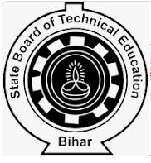
&

CONTENTS
1. Cover Page & Content

2. Vision of the Department

3. Mission of the department

4. Course Description & Course objectives

5. Course Syllabus

6. Reference Materials

7. Course outcomes (CO’s)

8. Time table

9. Student list

10. Lecture Plan

Department of Electronics Engineering

Vision
To be a centre of excellence in the field of Electronics Engineering offering value based world class education and research producing well qualified engineers, who can contribute favorably to the technological and socio-economic development of the nation.

Mission
1. To ensure sufficient modern technological exposure to the students in order to create skilled professionals.
2. To frequently update the labs keeping in view the requirement of the current industry scenario.
3. To extend counseling and career guidance facility to the students to help them to achieve their goal.
4. To encourage faculties and staffs to pursue higher education and to do the research work.
5. To encourage faculties and staffs to participate in various seminars, conferences and workshops to keep themselves updated of the state-of-the-art technology.

Course Description:-

Microwave engineering pertains to the study and design of microwave circuits, components, and systems. Fundamental principles are applied to analysis, design and measurement techniques in this field. The short wavelengths involved distinguish this discipline from electronic engineering. Microwave frequency usage is significant for the design of shipboard radar because it makes possible the detection of smaller targets. Microwave frequencies present special problems in transmission, generation, and circuit design that are not encountered at lower frequencies.

Course Objectives:-

The aim of this course is to help the students to attain the following industry identified competency through various teaching learning experiences:
Microwave Engineering introduces the student to RF/microwave analysis methods and design techniques. Scattering parameters are defined and used to characterize devices and system behavior. Passive and active devices commonly utilized in microwave subsystems are analyzed and studied.

Course Syllabus
ELECTIVE - (ANY ONE) - (v) MICTROWAVE ENGINEERING (ELECTRONICS ENGINEERING GROUP)
Subject Code 1621605E | Theory |  |  | No of Period in one session : |  |  | Credits
 | No. of Periods Per Week |  |  | Full Marks | : | 100 | 03
 | L | T | P/S | ESE | : | 70
 | 03 | — | — | TA | : | 10
 |  |  |  | CT | : | 20
Contents :Theory |  |  | Hrs/week | Marks
UNIT-1 | MICROWAVE TUBES:
 | 01.01 | Introduction.
 | 01.02 | Microwave frequency band spectrum.
 | 01.03 | Klystron.
 | 01.04 | Reflex Klystron.
 | 01.05 | Travelling Wave tubes. (TWT)
 | 01.06 | Magnetron.
UNIT-2 | MICROWAVE SEMI CONDUCTOR DEVICES:
 | 02.01 | Microwave Diodes.
 | 02.01.01 | Varactor Diodes.
 | 02.01.02 | Tunnel Diodes.
 | 02.01.03 | Gunn Diodes.
 | 02.01.04 | Avalanche effect diodes.
 | 02.02 | M A S E R.
UNIT-3 | MICROWAVE COMPONENTS AND ANTENNAS:
 | 03.01 | Coaxial Lines.
 | 03.02 | Wave guides.
 | 03.02.01 | Rectangular.
 | 03.02.02 | Circular.
 | 03.03 | Wave guide corners and Tees.
 | 03.04 | Directional couplers.
 | 03.05 | Attenualtors.
 | 03.06 | Antennas.
 | 03.07.01 | Parabolic.
 | 03.08.02 | Horn.
 | 03.09.03 | Slot.
Course Objectives: Microwave Engineering introduces the student to RF/microwave analysis methods and design techniques. Scattering parameters are defined and used to characterize devices and system behavior. Passive and active devices commonly utilized in microwave subsystems are analyzed and studied:

UNIT-4 | MICROWAVE TRANSMISSION:
 | 04.01 | Maxwells equations.
 | 04.02 | Modes of propagation in rectangular and circular wave guides.
 | 04.03 | Transmission through rectangular wave guide.
 | 04.04 | Cut off frequency and guide wave length.
 | 04.05 | Phase and group velocity, and relation between them.
UNIT-5 | DETECTORS:
 | 05.01 | Measurement of impedance.
 | 05.02 | Measurement of frequency.
 | 05.03 | Voltage standing wave ratio. (VSWR) and its measurement.
Total

Books Recommended:
- Microwave Communication. - Angelkos & Everhar.
- Foundation of Microwave Communication. - Collins.
- Microwaves. - Sanjeev Gupta & others.
- Electromagnetic Waves & Radiating Systems - Jordan.
- Microwave Theory & Measurement - Heylward Packard

Course outcomes:
The aim of the course is to provide a through coverage of fundamental principles of microwave engineering with focus on wireless communication system and high- speed data transmission. Besides enhancing general radio frequency circuit theory covered in previous courses, it introduces the fundamental of microwave circuit analysis and design, from electromagnetic theory to radar systems. Starting with a concise presentation of the electromagnetic theory, the course leads to passive and active microwave circuit design supported by complex Electronic Design Automation (EDA) software for high-frequency systems. After passing the course the student should know: Maxwell's and Helmholtz's equations, wave solutions, TEM, TE and TM wave propagation modes, and account for the relevant propagation modes for transmission lines Describe the concept of plane waves in different transmission media, polarized plane waves and plane wave reflection in mathematical form Compare the electromagnetic theory with transmission line theory in order to describe transmission lines from the point of view of either field theory or the circuit model Calculate the characteristic parameters of a rectangular waveguide Use Smith Chart to design matching networks Understand different concepts of impedance matching, i.e., narrow- and broadband impedance matching Describe, analyse and design basic passive and active microwave circuits such as couplers, amplifiers, mixers, oscillators Describe, analyse on system level different radarsystem, e.g., Doppler radar. Use radar equation, understand radar parameters and describe different modern radar applications. Carry out the design of microwave circuits using advanced simulation tools, including electromagnetic simulations
***************

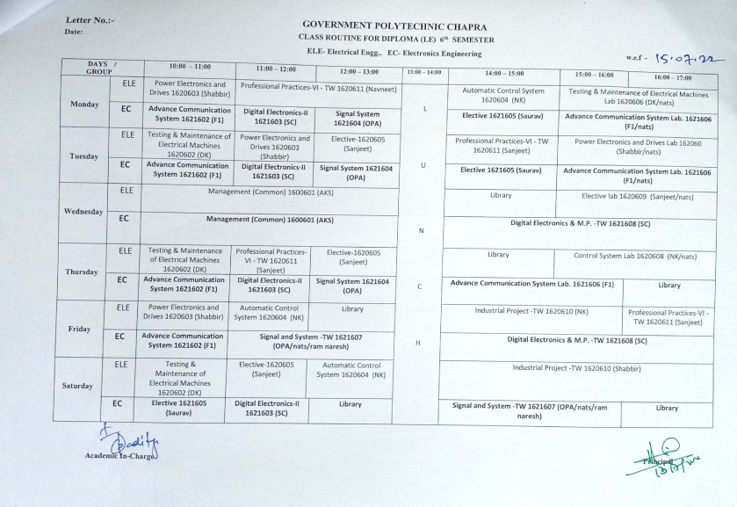

https://www.gpchhapra.org.in/2022/07/13/class-routine-notice/
TIME TABLE
FACULTY:- Prof.Saurav Kumar (Electronics Engineering Department)

GOVERNMENT POLYTECHNIC CHAPRA
CLASS ROUTINE FOR DIPLOMA 6th SEMESTER EC- Electronics Engineering

 | 1st  ^{10:00-11:00} | 2nd  ^{1:00-12:00} | 3rd  ^{12:00-1:00} |  | 4th  ^{2:00-3:00} | 5th  ^{3:00-4:00} | 6th  ^{4:00-5:00}
MON |  |  |  | L  U  N  C  H | Elective- Microwave Engineering 1621605(Saurav Kumar)
TUE |  |  |  |  | Elective- Microwave Engineering 1621605(Saurav Kumar)
WED
THU
FRI
SAT | Elective- Microwave Engineering 1621605(Saurav Kumar)

Student list
Electronics Engineering.

Roll Number | Name Of the Student
401/EC/20 | RAVI RANJAN KUMAR
402/EC/20 | MEGHNATH KR. KUSHWAHA
403/EC/20 | DEEPAK KR. YADAV
404/EC/20 | DILIP KUMAR PANDIT
405/EC/20 | MUKESH KUMAR
601/EC/20 | JULEE KUMARI
602/EC/20 | SUDHIR KUMAR
603/EC/20 | ABHIMANYU SINGH
604/EC/20 | NIDHI KUMARI
605/EC/20 | MD. IRFAN
606/EC/20 | RAHUL KR. MAHTO
607/EC/20 | RAHUL KUMAR
608/EC/20 | VBINIT KUMAR

LECTURE PLAN

Topics | Lecture Number
MICROWAVE TUBES: | 01-12
Introduction | 1-2
Microwave frequency band spectrum | 3-4
Klystron | 5
Reflex Klystron | 6-7
Travelling Wave tubes. (TWT) | 8-10
Magnetron | 11-12
MICROWAVE SEMI CONDUCTOR DEVICES: | 13-24
Microwave Diodes | 13-14
Varactor Diodes | 15-16
Tunnel Diodes | 17-18
Gunn Diodes | 19-20
Avalanche effect diodes | 21-22
M A S E R | 23-24
MICROWAVE COMPONENTS AND ANTENNAS: | 25-44
Coaxial Lines | 25-26
Wave guides | 27-28
Rectangular | 29-30
Circular | 31-32
Wave guide corners and Tees | 33-34
Directional couplers | 35-36
Attenualtors | 37-38
Antennas | 39-40
Parabolic, | 41-42
Horn, slot | 43-44
MICROWAVE TRANSMISSION: | 45-54
Maxwells equations | 45-46
Modes of propagation in rectangular and circular wave guides | 47-48
Transmission through rectangular wave guide | 49-50
-Cut off frequency and guide wave length | 51-52
Phase and group velocity, and relation between them | 53-54
DETECTORS: | 55-60
Measurement of impedance | 55-56
Measurement of frequency | 57-58
Voltage standing wave ratio. (VSWR) and its measurement | 59-60

This document is approved by
Designation | Name | Signature
Course Coordinator | Prof. Saurav Kumar
HoD | Prof. Om Prakash Aditya
Principal | Dr. Anil Kumar Singh
Date

