GOVERNMENT POLYTECHNIC
CHHAPRA
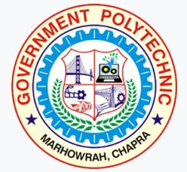
COURSE FILE (Lecture Plan)
OF
CONSUMER ELECTRONICS (2021402)

Faculty Name:
Prof. SAURAV KUMAR
Lecturer

DEPARTMENT OF ELECTRONICS ENGINEERING

STATE BOARD OF TECHNICAL EDUCATION
Bihar, Patna
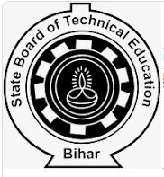
&

CONTENTS
1. Cover Page & Content

2. Vision of the Department

3. Mission of the department

4. Course Description & Course objectives

5. Course Syllabus

6. Reference Materials

7. Course outcomes (CO’s)

8. Time table

9. Student list

10. Lecture Plan

Department of Electronics Engineering

Vision
To be a centre of excellence in the field of Electronics Engineering offering value based world class education and research producing well qualified engineers, who can contribute favorably to the technological and socio-economic development of the nation.

Mission
1. To ensure sufficient modern technological exposure to the students in order to create skilled professionals.
2. To frequently update the labs keeping in view the requirement of the current industry scenario.
3. To extend counseling and career guidance facility to the students to help them to achieve their goal.
4. To encourage faculties and staffs to pursue higher education and to do the research work.
5. To encourage faculties and staffs to participate in various seminars, conferences and workshops to keep themselves updated of the state-of-the-art technology.

Course Description:-

Consumer electronics or home electronics are electronic (analog or digital) equipment intended for everyday use, typically in private homes. Consumer electronics include devices used for entertainment, communications and recreation. This course will introduce the students with working principles, of consumer electronics appliances like audio-video systems, microwave oven, washing machine, air-conditioner, camcorder and others to develop skills to troubleshoot in systematic way.

Course Objectives:-

The aim of this course is to help the students to attain the following industry identified competency through various teaching learning experiences:
- Maintain various consumer electronic appliances/equipment’s

Course Syllabus
CONSUMER ELECTRONICS (ELECTRONICS ENGINEERING GROUP)

Subject Code 2021402 | Theory |  |  |  |  |  | Credits
 | No. of Periods Per Week |  |  | Full Marks | : | 100 | 03
 | L | T | P/S | ESE | : | 70
 | 03 | - | - | TA | : | 10
 | - | - | - | CT | : | 20

Course Objectives: The aim of this course is to help the students to attain the following industry identified competency through various teaching learning experiences: Maintain various consumer electronic appliances/ equipment’s.

Chapter | Name of the Topic | Hours
Unit I | Audio Fundamentals and Devices  Basic characteristics of sound signal, Audio level metering, decibel level in acoustic measurement Microphone & Types, speaker types & working principle, Sound recording principle & types. | 12
Unit II | Audio Systems  CD player, home theatre sound system, surround sound, Digital console block diagram, working principle, applications, FM tuner , ICs used in FM tuner TDA 7021T , PA address system. | 12
Unit III | Television Systems-  Monochrome TV standards, scanning process, aspect ratio, persistence of vision and flicker, interlace scanning, picture resolution, Composite video signal, Colour TV standards, colour theory, hue, brightness, saturation, luminance and chrominance, Different types of TV camera, Transmission standards. | 14
Unit IV | Television Receivers and Video Systems-  PAL-D colour TV receiver, Digital TVs:- LCD, LED , PLASMA, HDTV, 3- D TV, projection TV, DTH receiver, Video interface,  Digital Video, SDI, HDMI Multimedia Interface, Digital Video Interface, CD and DVD player. | 12
Unit V | Home / Office Appliances  Diagrams, operating principles and controller for FAX and Photocopier, Microwave Oven, Washing Machine, Air conditioner and Refrigerators, Digital camera and camcoder. | 10
 | TOTAL | 60

References:

S. No. | Title of Book | Author | Publication
1. | Consumer Electronics | Bali S.P. | Pearson Education India,2010 , latest edition
2. | Audio video systems : principle practices & troubleshooting | Bali R and Bali S.P | Khanna Book Publishing Co. (P)  Ltd., 2010Delhi , India, latest edition
3. | Modern Television practices | Gulati R.R. | New Age International Publication  (P) Ltd. New Delhi Year 2011, latest edition
4. | Audio video systems | Gupta R.G. | Tata Mc graw Hill, New Delhi, India 2010, latest  edition
5. | Mastering Digital Television | Whitaker Jerry & Benson Blair | McGraw-Hill Professional, 2010, latest edition
6. | Consumer Electronics | Neeraj Sharma | FPH (Foundation Publishing House)
7. | Standard hand book of Audio engineering | Whitaker Jerry & Benson Blair | McGraw-Hill Professional, 2010, latest edition.

Course outcomes:
The theory, practical experiences and relevant soft skills associated with this course are to be taught and implemented, so that the student demonstrates the following industry oriented COs associated with the above mentioned objective:
- Different types of microphones and speakers
- Maintain audio systems
- Analyse the composite video signal used in TV signal transmission
- Troubleshoot colour TV receiver
- Maintain various consumer electronic appliances

***************

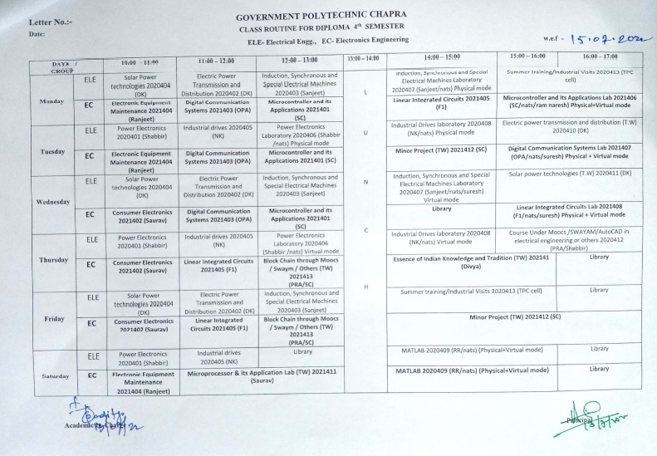

https://www.gpchhapra.org.in/2022/07/13/class-routine-notice/
TIME TABLE
FACULTY:- Prof.Saurav Kumar (Electronics Engineering Department)

GOVERNMENT POLYTECHNIC CHAPRA
CLASS ROUTINE FOR DIPLOMA 4th SEMESTER EC- Electronics Engineering

 | 1st  ^{10:00-11:00} | 2nd  ^{1:00-12:00} | 3rd  ^{12:00-1:00} |  | 4th  ^{2:00-3:00} | 5th  ^{3:00-4:00} | 6th  ^{4:00-5:00}
MON |  |  |  | L  U  N  C  H
TUE
WED | Consumer Electronics 2021402 (Saurav Kumar)
THU | Consumer Electronics 2021402 (Saurav Kumar)
FRI | Consumer Electronics 2021402 (Saurav Kumar)
SAT

Student list
Electronics Engineering.
Roll Number | Name Of the Student
311132120001 | AKANSKSHA KUMARI
311132120002 | ABHISHEK RAJAK
311132120003 | SULEKHA KUMARI
311132120004 | ABHISHEK KUMAR UPADHAYAY
311132120006 | DILIP KUMAR RAM
311132120008 | SANDHYA KUMARI
311132120009 | MONIKA KUMARI
311132120010 | ANAND KUMAR SINGH
311132120011 | SUMIT KUMAR SINGH
311132120012 | AAYUSHI KUMARI
311132120013 | ANANYA KUMARI
311132120014 | ANKIT KANT
311132120015 | KUMAR RAVI
311132120016 | ROHIT KUMAR PANDEY
311132120017 | SALMAN ALAM
311132120018 | ROHIT KUMAR BHARTI
311132120019 | NIKKI KUMARI
311132120020 | SONU KUMAR SINGH
311132120021 | MD. ARMANUL HAQUE
311132120022 | DEEP KUMAR
311132120023 | GAJENDRA KUMAR SINGH
311132120024 | SUBHAM KUMAR
311132120025 | UTSAV KUMAR TIWARI
311132120026 | SHAJZAD KHAN
311132120027 | SAMIR KUMAR
311132120028 | PAWAN KUMAR
311132120029 | CHANDAN KUMAR
311132120030 | ADITYA KUMAR
311132120031 | RANI KUMARI
311132120032 | DIWAKAR KUMAR
311132120033 | ADITYA KUMAR BHAGAT
311132120034 | BHIM MANJHI

311132120035 | AMAN KUMAR RAM
311132120036 | VISHAL KUMAR GAURAV
311132120037 | VIKASH KUMAR
311132120038 | SUMIT KUMAR SHARMA
311132120039 | AKRAR AHMAD
311132120040 | KRISHNA KUMAR SHARMA
311132120042 | GITANJALI KUMARI
311132120043 | AMIT KUMAR
311132120044 | NITISH KUMAR
311132120045 | NIRANJAN KUMAR
311132120046 | RISHABH KUMAR
311132120047 | JAGMOHAN KUMAR
311132120049 | ABHISHEK KUMAR
311132120050 | SONIKA KUMARI
311132120052 | MD IMTIYAZ
311132120053 | MUNMUN KUMAR
311132120054 | PRADUM KUMAR
311132120301 | MAMTA KUMARI
601/EC/21 | CHANDAN KUMAR VIDYARTHI
602/EC/21 | DIPAK KUMAR
603/EC/21 | SURAJ KUMAR
604/EC/21 | RAUSHAN KUMAR
605/EC/21 | NITISH KUMAR
606/EC/21 | AASTHA PRIYA
607/EC/21 | RAM PRAKASH SHAH
608/EC/21 | ADITYA KUMAR MAURYA
609/EC/21 | SATYAM JEE
610/EC/21 | MANTU KUMAR PAL
611/EC/21 | SANOJ KUMAR PRASAD
612/EC/21 | SUNNY KUMAR

LECTURE PLAN

Topics | Lecture Number
Audio Fundamentals and Devices: | 01-12
Basic characteristics of sound signal | 1-2
Audio level metering | 3-4
Decibel level in acoustic measurement | 5
Microphone & Types | 6-7
Speaker types & working principle | 8
Speakers working principle | 9-10
Sound recording principle & types | 11-12
Audio Systems: | 13-24
CD player | 13
Home theatre sound system | 14
Surround sound | 15-16
Digital console block diagram | 17-18
Working principle and its applications | 19-20
FM tuner | 21
ICs used in FM tuner TDA 7021T | 22-23
PA address system | 24
Television Systems: | 25-38
Monochrome TV standards | 25
Scanning process | 26
Aspect ratio, Persistence of vision and Flicker | 27-28
Interlace scanning | 29
Picture resolution, Composite video signal | 30-31
Colour TV standards | 32
Colour theory, Hue, Brightness, Saturation | 33-34
Luminance and chrominance | 35
Different types of TV camera | 36-37
Transmission standards | 38
Television Receivers and Video Systems: | 38-50
PAL-D colour TV receiver | 38-39
Digital TVs:- LCD, LED , PLASMA, HDTV, 3- D TV, projection TV | 40-43
DTH receiver | 43
Video interface | 44
Digital Video | 45
SDI, HDMI Multimedia Interface | 46-47
Digital Video Interface | 48
CD and DVD player | 49-50
Home / Office Appliances: | 51-60
Diagrams, operating principles and controller for FAX and Photocopier | 51-52
Microwave Oven | 53-54
Washing Machine | 55-56
Air conditioner and Refrigerators | 57-58
Digital camera and camcoder | 59-60

This document is approved by
Designation | Name | Signature
Course Coordinator | Prof. Saurav Kumar
HoD | Prof. Om Prakash Aditya
Principal | Dr.Anil Kumar Singh
Date

