GOVERNMENT POLYTECHNIC
CHHAPRA
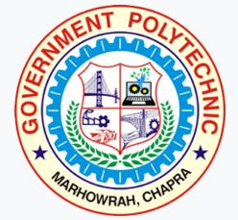
COURSE FILE (Lecture Plan)
OF
Microprocessor & its Application Lab (TW) (2021411)

Faculty Name:
Prof. SAURAV KUMAR
Lecturer

DEPARTMENT OF ELECTRONICS ENGINEERING

STATE BOARD OF TECHNICAL EDUCATION
Bihar, Patna
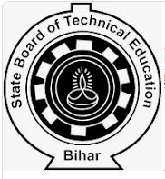
&
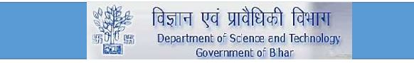

CONTENTS
1. Cover Page & Content

2. Vision of the Department

3. Mission of the department

4. Course Description & Course objectives

5. Course Syllabus

6. Reference Materials

7. Course outcomes (CO’s)

8. Time table

9. Student list

10. Lecture Plan

Department of Electronics Engineering

Vision
To be a centre of excellence in the field of Electronics Engineering offering value based world class education and research producing well qualified engineers, who can contribute favorably to the technological and socio-economic development of the nation.

Mission
1. To ensure sufficient modern technological exposure to the students in order to create skilled professionals.
2. To frequently update the labs keeping in view the requirement of the current industry scenario.
3. To extend counseling and career guidance facility to the students to help them to achieve their goal.
4. To encourage faculties and staffs to pursue higher education and to do the research work.
5. To encourage faculties and staffs to participate in various seminars, conferences and workshops to keep themselves updated of the state-of-the-art technology.

Course Description:-

This course deals with the systematic study of the Architecture and programming issues of 8 bit 8085-microprocessor and interfacing with other peripheral ICs and co-processor. In addition, a 16-bit microprocessors and other chips (8255, 8251, 8253 and 8257) are introduced. The aim of this course is to give the students basic knowledge of the microprocessors (8085 and 8086) needed to develop the systems using it. The course outcomes are: 1. Understand the architecture of 8085 and 8086. 2. Impart the knowledge about the instruction set. 3. Understand the basic idea about the data transfer schemes and its applications. 4. Develop skill in simple program writing for 8085 & 8086 and applications.

Course Objectives:-

The aim of this course is to help the students to attain the following industry identified competency through various teaching learning experiences:
Maintain microcontroller based systems

Course Syllabus
MICROPROCESSORS AND ITS APPLICATION LAB (TW)
Subject Code (2021411) | Term Work |  |  |  |  |  | Credits
 | No. of Periods Per Week |  |  | Full Marks | : | 25 | 01
 | L | T | P/S | Internal | : | 07
 | - | - | 02 | External | : | 18
 | - | - | - | - | - | -

Course Objectives: The aim of this course is to help the students to attain the following industry identified competency through various teaching learning experiences:
Maintain microcontroller based systems
CONTENTS: PRACTICAL

Intellectual Skills:
- Logical development.
- Programming skills.

Motor Skills:
- Data entry, Error Correction and Execution of assembly language programs.
- Connection Skills.
List of Practicals:
- Using microprocessor 8085 kit:
  - Demonstration and study of microprocessor kit
  - Program for addition of and subtraction of two hexadecimal numbers
  - Program for finding largest / smallest number
  - Program for arranging numbers in ascending / descending order
  - Program for 16 bit addition
  - Program for data masking
  - Program for multiplication of two eight bit numbers
  - Program using JMP Instruction
  - Two programs using loop

Course outcomes:
The theory, practical experiences and relevant soft skills associated with this course are to be taught and implemented, so that the student demonstrates the following industry oriented COs associated with the above mentioned objective: At the end of this course, students will be able to CO1: Understand the basic architecture of 8085 and 8086. CO2: Impart the knowledge about the instruction set. CO3: Understand the basic idea about the data transfer schemes and its applications CO4: Develop skill in simple program writing for INTEL 8085 and INTEL 8086

***************

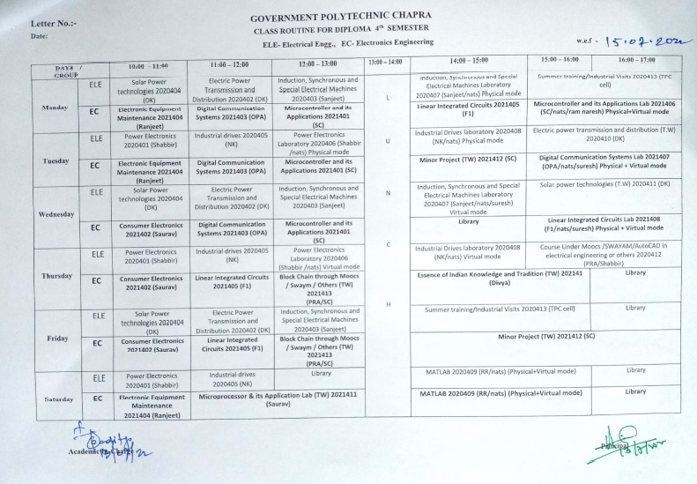

https://www.gpchhapra.org.in/2022/07/13/class-routine-notice/
TIME TABLE
FACULTY:- Prof.Saurav Kumar (Electronics Engineering Department)

GOVERNMENT POLYTECHNIC CHAPRA
CLASS ROUTINE FOR DIPLOMA 4th SEMESTER EC- Electronics Engineering

 | 1st  ^{10:00-11:00} | 2nd  ^{1:00-12:00} | 3rd  ^{12:00-1:00} |  | 4th  ^{2:00-3:00} | 5th  ^{3:00-4:00} | 6th  ^{4:00-5:00}
MON |  |  |  | L  U  N  C  H
TUE
WED
THU
FRI
SAT |  | Microprocessor & its Application Lab (TW) 2021411 (Saurav Kumar)

Student list
Electronics Engineering.
Roll Number | Name Of the Student
311132120001 | AKANSKSHA KUMARI
311132120002 | ABHISHEK RAJAK
311132120003 | SULEKHA KUMARI
311132120004 | ABHISHEK KUMAR UPADHAYAY
311132120006 | DILIP KUMAR RAM
311132120008 | SANDHYA KUMARI
311132120009 | MONIKA KUMARI
311132120010 | ANAND KUMAR SINGH
311132120011 | SUMIT KUMAR SINGH
311132120012 | AAYUSHI KUMARI
311132120013 | ANANYA KUMARI
311132120014 | ANKIT KANT
311132120015 | KUMAR RAVI
311132120016 | ROHIT KUMAR PANDEY
311132120017 | SALMAN ALAM
311132120018 | ROHIT KUMAR BHARTI
311132120019 | NIKKI KUMARI
311132120020 | SONU KUMAR SINGH
311132120021 | MD. ARMANUL HAQUE
311132120022 | DEEP KUMAR
311132120023 | GAJENDRA KUMAR SINGH
311132120024 | SUBHAM KUMAR
311132120025 | UTSAV KUMAR TIWARI
311132120026 | SHAJZAD KHAN
311132120027 | SAMIR KUMAR
311132120028 | PAWAN KUMAR
311132120029 | CHANDAN KUMAR
311132120030 | ADITYA KUMAR
311132120031 | RANI KUMARI
311132120032 | DIWAKAR KUMAR
311132120033 | ADITYA KUMAR BHAGAT
311132120034 | BHIM MANJHI

311132120035 | AMAN KUMAR RAM
311132120036 | VISHAL KUMAR GAURAV
311132120037 | VIKASH KUMAR
311132120038 | SUMIT KUMAR SHARMA
311132120039 | AKRAR AHMAD
311132120040 | KRISHNA KUMAR SHARMA
311132120042 | GITANJALI KUMARI
311132120043 | AMIT KUMAR
311132120044 | NITISH KUMAR
311132120045 | NIRANJAN KUMAR
311132120046 | RISHABH KUMAR
311132120047 | JAGMOHAN KUMAR
311132120049 | ABHISHEK KUMAR
311132120050 | SONIKA KUMARI
311132120052 | MD IMTIYAZ
311132120053 | MUNMUN KUMAR
311132120054 | PRADUM KUMAR
311132120301 | MAMTA KUMARI
601/EC/21 | CHANDAN KUMAR VIDYARTHI
602/EC/21 | DIPAK KUMAR
603/EC/21 | SURAJ KUMAR
604/EC/21 | RAUSHAN KUMAR
605/EC/21 | NITISH KUMAR
606/EC/21 | AASTHA PRIYA
607/EC/21 | RAM PRAKASH SHAH
608/EC/21 | ADITYA KUMAR MAURYA
609/EC/21 | SATYAM JEE
610/EC/21 | MANTU KUMAR PAL
611/EC/21 | SANOJ KUMAR PRASAD
612/EC/21 | SUNNY KUMAR

LECTURE PLAN

Topics | Lecture Number
Intellectual Skills:
Logical development | 1-2
Programming skills | 3-4
Motor Skills:
Data entry, Error Correction and Execution of assembly language programs | 6-7
Connection Skills | 8-9
List of Practical’s:
Using microprocessor 8085 kit:
Demonstration and study of microprocessor kit | 10-11
Program for addition of and subtraction of two hexadecimal numbers | 12-13
Program for finding largest / smallest number | 14-15
Program for arranging numbers in ascending / descending order | 16-17
Program for 16 bit addition | 18-19
Program for data masking | 20-21
Program for multiplication of two eight bit numbers | 22
Program using JMP Instruction | 23
Two programs using loop | 24

This document is approved by
Designation | Name | Signature
Course Coordinator | Prof. Saurav Kumar
HoD | Prof. Om Prakash Aditya
Principal | Dr. Anil Kumar Singh
Date

