COURSE FILE
Engineering Graphics
DIPLOMA 2nd SEM.
PRO. MUKESH KUMAR
DEPARTMENT OF AUTOMOBILE ENGINEERING

GOVERNMENT POLYTECHNIC CHAPRA

CONTENTS

- Time table

- Vision of the Department

- Mission of the department

- Course Syllabus

- Reference Materials

- Student list

- 10.Lecture Plan

- Question Bank

Time table

 | 1st  ^{10:00-11:00} | 2nd  ^{1:00-12:00} | 3rd  ^{12:00-1:00} |  | 4th  ^{2:00-3:00} | 5th  ^{3:00-4:00} | 6th  ^{4:00-5:00}
MON |  |  |  | L  U  N  C  H
TUE
WED
THU
FRI
SAT

Vision
To be a centre of excellence in the field of Mechanical Engineering offering value based world class education and research producing well qualified engineers, who can contribute favorably to the technological and socio-economic development of the nation.

Mission
1. To ensure sufficient modern technological exposure to the students in order to create skilled professionals.
2. To frequently update the labs keeping in view the requirement of the current industry scenario.
3. To extend counseling and career guidance facility to the students to help them to achieve their goal.
4. To encourage faculties and staffs to pursue higher education and to do the research work.
5. To encourage faculties and staffs to participate in various seminars, conferences and workshops to keep themselves updated of the state-of-the-art technology.

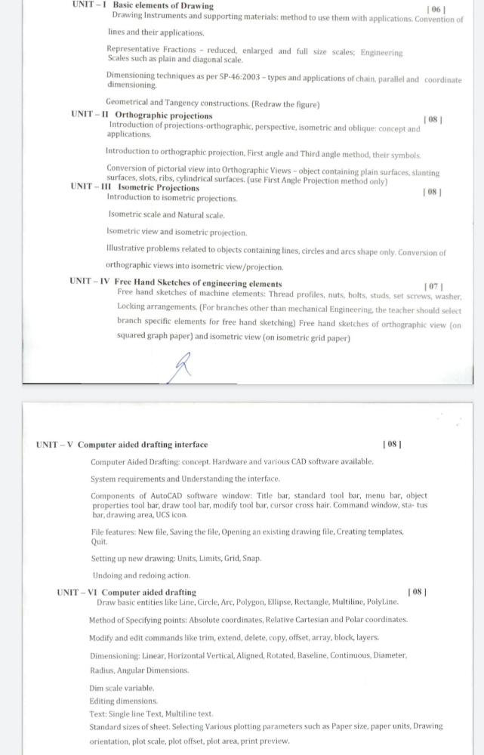
Text/ Reference Books:
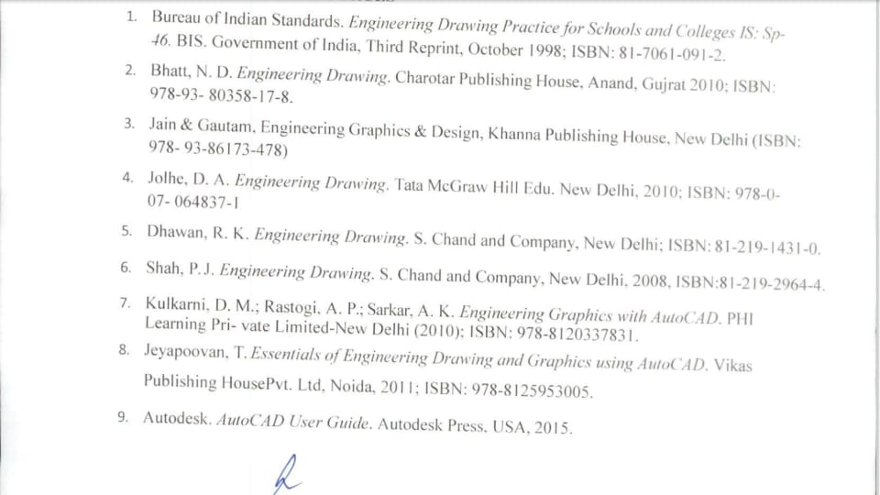

Lecture plan
Unit | Name of Topic | No. of Lecture | Date
01 | Drawing Instruments and supporting materials Convention of lines and their applications. | Lec-1 | 15/7/22
 | Representative Fractions - reduced, enlarged and full size scales; | Lec-2 | 18/7/22
 | Engineering Scales such as plain | Lec-3 | 21/7/22
 | diagonal scale. | Lec-4 | 22/7/22
 | Dimensioning techniques types and applications of chain, parallel and coordinate dimensioning. | Lec-5 | 25/7/22
 | Geometrical and Tangency constructions | Lec-6 | 28/7/22
 | Class test-01 |  | 29/7/22
Assignment-01

Unit | Name of Topic | No. of Lecture | Date
02 | Introduction of projections-orthographic, perspective, isometric and oblique: concept and applications. | Lec-7 | 1/8/22
 | Introduction to orthographic projection | Lec-8 | 4/8/22
 | First angle and Third angle method, their symbols. | Lec-9 | 5/8/22
 | Conversion of pictorial view into Orthographic Views | Lec-10 | 8/8/22
 | object containing plain surfaces | Lec-11 | 11/8/22
 | object containing solid surfaces | Lec-12 | 18/8/22
 | slanting surfaces | Lec-13 | 22/8/22
 | slots, ribs, cylindrical surfaces. | Lec-14 | 25/8/22
 | Class test-02 |  | 26/8/22
Assignment-02

Unit | Name of Topic | No. of Lecture | Date
03 | Introduction to isometric projections | Lec-15 | 1/9/22
 | Isometric scale and Natural scale. | Lec-16 | 2/9/22
 | Isometric view and isometric projection | Lec-17 | 5/9/22
 | Conversion of pictorial view into Orthographic Views | Lec-18 | 8/9/22
 | Illustrative problems related to objects containing lines, circles | Lec-19 | 9/9/22
 | Illustrative problems related to objects containing arcs shape only. | Lec-20 | 12/9/22
 | Conversion of orthographic views into isometric view | Lec-21 | 15/9/22
 | Conversion of orthographic views into isometricprojection. | Lec-22 | 16/9/22
 | Class test-03 |  | 19/9/22
Assignment-03

Unit | Name of Topic | No. of Lecture | Date
04 | Free Hand Sketches of engineering elements | Lec-23 | 22/9/22
 | Free hand sketches of machine elements: Thread profiles, | Lec-24 | 23/9/22
 | studs, set screws, | Lec-25 | 26/9/22
 | Locking arrangements. (For branches other than mechanical Engineering) | Lec-26 | 29/9/22
 | Free hand sketches of orthographic view | Lec-27 | 30/9/22
 | Free hand sketches of isometric view | Lec-28 | 10/10/22
 | Nuts, washer | Lec-29 | 13/10/22
 | Class test-04 |  | 14/10/22
Assignment-04

Unit | Name of Topic | No. of Lecture | Date
05 | Computer Aided Drafting: concept. Hardware and various CAD software available. | Lec-30 | 17/10/22
 | System requirements and Understanding the interface. | Lec-31 | 20/10/22
 | Components of AutoCAD software window: Title bar, standard tool bar, menu bar, | Lec-32 | 21/10/22
 | object properties tool bar, draw tool bar, modify tool bar, cursor cross hai | Lec-33 | ………
 | Command window, sta- tus har, drawing area, UCS icon. | Lec-34 | ………
 | File features: New file, Saving the file, Opening an existing drawing file, Creating templates, Quit | Lec-35 | ………
 | Setting up new drawing: Units, Limits, Grid, Snap | Lec-36 | ………
 | Undoing and redoing action | Lec-37 | ………
 | Class test-05
Assignment-05

Unit | Name of Topic | No. of Lecture | Date
06 | Draw basic entities like Line, Circle, Arc, Polygon, Ellipse, Rectangle, Multiline, PolyLine | Lec-38 | ………
 | Method of Specifying points: Absolute coordinates, Relative Cartesian and Polar coordinates. | Lec-39 | ………
 | Modify and edit commands like trim, extend, delete, copy, offset, array, block, layers. | Lec-40 | ………
 | Dimensioning: Linear, Horizontal Vertical, Aligned, Rotated, Baseline, Continuous, Diameter, | Lec-41 | ………
 | Radius, Angular Dimensions. | Lec-42 | ………
 | Dim scale variable. Editing dimensions.  Text: Single line Text, Multiline text. | Lec-43 | ………
 | Standard sizes of sheet. Selecting Various plotting parameters such as Paper size | Lec-44 | ………
 | , paper units, Drawing orientation, plot scale, plot offset, plot area, print preview. | Lec-45 | ………
 | Class test-06 |  | ………
Assignment-06

Students list
Branch-Civil Engg.
Roll Number | Name Of the Student
111131521001 | PUSKAR SINGH
111131521002 | AKASH KUMAR
111131521003 | ABHISHEK KUMAR
111131521004 | ROHIT KUMAR
111131521005 | PRABHAT TRIVEDI
111131521006 | SUJIT KUMAR
111131521007 | ABHISHEK KUMAR
111131521008 | RAHUL KUMAR PRASAD
111131521009 | AMAN KUMAR
111131521010 | SANDIP KUMAR
111131521011 | VINOD KUMAR
111131521012 | DHANANJAY KUMAR
111131521013 | RAUSHAN KUMAR
111131521014 | RAJEEV KUMAR DAS
111131521015 | HARSH RAJ PRAJAPATI
111131521016 | AARAV KUMAR SHARMA
111131521017 | FANISHWAR KUMAR
111131521018 | NITIN KUMAR
111131521019 | RAVI KUMAR
111131521020 | VINAY KUMAR
111131521021 | RAVI KUMAR
111131521022 | RANDHIR KUMAR
111131521023 | NAVEEN KUMAR
111131521024 | ARCHANA KUMARI
111131521025 | RITESH KUMAR
111131521026 | AMAN KUMAR
111131521027 | KUNDAN KUMAR
111131521028 | PRASANT RAJ
111131521029 | MD IMRAN
111131521030 | SUNNY KUMAR
111131521031 | ANKIT KUMAR
111131521032 | BHAWESH KUMAR BHARTI
111131521033 | SANGAM KUMAR
111131521034 | AQUIB HUSSAIN
111131521035 | PRATIMA KUMARI
111131521036 | NAVIN KUMAR NIRALA
111131521037 | ANKIT KUMAR
111131521038 | BHASKAR KUMAR
111131521039 | CHANDAN RAJ
111131521040 | ANKIT RAJ
111131521041 | SANNY KUMAR
111131521042 | AKSHUNYA KUMAR
111131521043 | ABHISHEK KUMAR
111131521044 | MANISH KUMAR
111131521045 | RAVIKANT KUMAR
111131521046 | SANKALP KUMAR
111131521047 | ANUJ KUMAR PANDIT
111131521048 | CHHOTU KUMAR
111131521049 | KARISHMA KUMARI
111131521050 | RATAN KUMAR
111131521051 | SURAJ KUMAR
111131521052 | RANJESH KUMAR
111131521053 | PRINCE KUMAR THAKUR
111131521054 | MD AARIF KHAN
111131521301 | PRITAM RAJ
111131521302 | ABHINAV KUMAR
111131521303 | MANISH KUMAR
Branch-Electronics Engg.
Roll Number | Name Of the Student
111132121001 | OMPRAKASH GIRI
111132121002 | SHIVAM KUMAR
111132121003 | ASTHA KUMARI
111132121004 | RITESH KUMAR
111132121005 | RESHMI KUMARI
111132121006 | PUSHP RAJ SINGH
111132121007 | ANWESHA SINGH
111132121008 | RAHUL KUMAR PANDEY
111132121009 | SUNNY KUMAR
111132121010 | SUJEET KUMAR
111132121011 | RAJ DEEPAK
111132121012 | PINTU KUMAR
111132121013 | AMAR RAJ
111132121014 | NEHA KUMARI
111132121015 | BEAUTY KUMARI
111132121016 | VISHAL KUMAR
111132121017 | SANDEEP KUMAR
111132121018 | KARAN KUMAR
111132121019 | HASAN RAJA
111132121020 | ANKIT KUMAR
111132121021 | ROHIT KUMAR
111132121022 | VIKASH KUMAR
111132121023 | SUDHANSHU KUMAR
111132121024 | MOHIT KUMAR
111132121025 | ALOK KUMAR SINGH
111132121026 | MONU KUMAR
111132121027 | MONU KUMAR
111132121028 | AMAN KUMAR
111132121029 | ROHIT KUMAR
111132121030 | PRINCE KUMAR
111132121031 | GAUTAM RANJAN
111132121032 | ANKIT KUMAR
111132121033 | RAUSHAN KUMAR
111132121034 | DINKAR KUMAR
111132121035 | MOHAMMAD ALI
111132121036 | AMAN KUMAR
111132121037 | ROZEE KHATOON
111132121038 | RANJEET KUMAR
111132121039 | PRATAP KUMAR SHARMA
111132121040 | RAHUL KUMAR
111132121041 | SANDEEP KUMAR
111132121042 | RAUSHAN KUMAR
111132121043 | AJAY KUMAR
111132121044 | ANIKET KUMAR CHOUDHARY
111132121045 | POOJA KUMARI
111132121301 | RITESH KUMAR GUPTA
111132121302 | GOVIND KUMAR SAHANI
111132121303 | PUSHPA KUMARI

