COURSE FILE
AUTOMOBILE SYSTEM (2033401)
DIPLOMA 4TH SEM.
PRO. MUKESH KUMAR
DEPARTMENT OF AUTOMOBILE ENGINEERING

GOVERNMENT POLYTECHNIC CHAPRA

CONTENTS

- Time table

- Vision of the Department

- Mission of the department

- Course Syllabus

- Reference Materials

- Lecture Plan

- Student list

- Question Bank

Time table
 | 1st  ^{10:00-11:00} | 2nd  ^{1:00-12:00} | 3rd  ^{12:00-1:00} |  | 4th  ^{2:00-3:00} | 5th  ^{3:00-4:00} | 6th  ^{4:00-5:00}
MON |  |  |  | L  U  N  C  H
TUE
WED
THU
FRI
SAT

Department of Automobile Engineering

Vision
To be a centre of excellence in the field of Mechanical Engineering offering value based world class education and research producing well qualified engineers, who can contribute favorably to the technological and socio-economic development of the nation.

Mission
1. To ensure sufficient modern technological exposure to the students in order to create skilled professionals.
2. To frequently update the labs keeping in view the requirement of the current industry scenario.
3. To extend counseling and career guidance facility to the students to help them to achieve their goal.
4. To encourage faculties and staffs to pursue higher education and to do the research work.
5. To encourage faculties and staffs to participate in various seminars, conferences and workshops to keep themselves updated of the state-of-the-art technology.
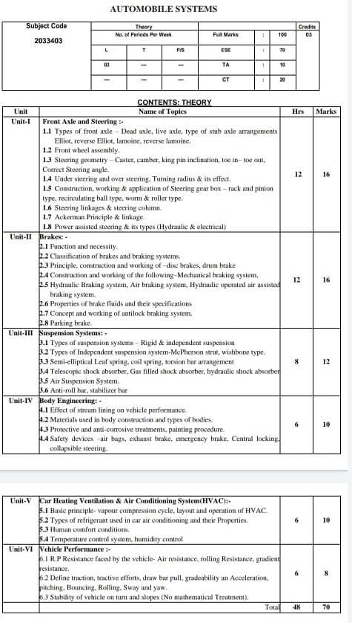
Text/ Reference Books:
1. Motor Automotive Technology --Anthony Schwaller --Delmar Publisher Inc.
2. Automotive Service --Tim Gills --Delmar Publisher Inc.
3. Automobile Engineering Vol. II --Anil Chikara --Satya Prakashan New Delhi
4. Automobile Mechanics --Crouse / Anglin. --TATA McGRAW – HILL
5. Automobile Engineering --Vol.I Kirpal Singh --Standard Publication
6. Automobile Engineering --R.B. Gupta --Satya Prakashan New Delhi
7. Automotive Mechanics --S. Srinivisan --TATA McGRAW – HILL
8. ASHRAE HANDBOOK OF HVAC—ASHRAE
9. Automobile Air Conditioning --Boyce H. Dwiggins --THOMSON LEARNING
10. Automotive technology: A system Approach --Jack Erjavec
11. Automobile Electrical and Electronic systems --Tom Denton

Lecture plan
Unit | Name of Topic | No. of Lecture
01 | Types of front axle – Dead axle, live axle, | Lec-1
 | type of stub axle arrangements Elliot | Lec-2
 | , reverse Elliot, lamoine, reverse lamoine | Lec-3
 | Front wheel assembly. | Lec-4
 | Steering geometry – Caster, camber, king pin inclination, | Lec-5
 | toe in– toe out, Correct Steering angle | Lec-6
 | Under steering and over steering, Turning radius & its effect | Lec-7
 | Construction, working & application of Steering gear box – rack and pinion type | Lec-8
 | , recirculating ball type, worm & roller type. | Lec-9
 | Steering linkages & steering column. | Lec-10
 | Ackerman Principle & linkage | Lec-11
 | . Power assisted steering & its types (Hydraulic & electrical) | Lec-12
 | Class test-01

Unit | Name of Topic | No. of Lecture
02 | Function and necessity | Lec-13
 | Classification of brakes | Lec-14
 | braking systems.. | Lec-15
 | Principle, construction and working of –disc brakes, | Lec-16
 | drum brake | Lec-17
 | Construction and working of the following–Mechanical braking system | Lec-18
 | Hydraulic Braking system | Lec-19
 | , Air braking system, Hydraulic operated air assisted braking system. | Lec-20
 | Properties of brake fluids | Lec-21
 | of brake fluids SPECIFICATION | Lec-22
 | Concept and working of antilock braking system. | Lec-23
 | Parking brake | Lec-24
 | Class test-02

Unit | Name of Topic | No. of Lecture
03 | Types of suspension systems – Rigid & independent suspension | Lec-25
 | Types of Independent suspension system-McPherson strut, wishbone type. | Lec-26
 | Semi-elliptical Leaf spring, | Lec-27
 | coil spring, torsion bar arrangement | Lec-28
 | Telescopic shock absorber, Gas filled shock absorber, | Lec-29
 | hydraulic shock absorber | Lec-30
 | Air Suspension System | Lec-31
 | Anti-roll bar, stabilizer bar | Lec-32
 | Class test-03

Unit | Name of Topic | No. of Lecture
04 | Effect of stream lining on vehicle performance | Lec-33
 | Materials used in body construction and | Lec-34
 | types of bodies. | Lec-35
 | Protective and anti-corrosive treatments, painting procedure. | Lec-36
 | Safety devices –air bags, exhaust brake, | Lec-37
 | emergency brake, Central locking, collapsible steering. | Lec-38
 | Class test-04

Unit | Name of Topic | No. of Lecture
05 | Basic principle- vapour compression cycle, | Lec-39
 | layout and operation of HVAC | Lec-40
 | Types of refrigerant used in car air conditioning | Lec-41
 | Cae AC Properties. | Lec-42
 | Human comfort conditions | Lec-43
 | Temperature control system, humidity control | Lec-44
 | Class test-05

Unit | Name of Topic | No. of Lecture
06 | R.P Resistance faced by the vehicle- | Lec-45
 | Air resistance, rolling Resistance, gradient resistance. | Lec-46
 | Define traction, tractive efforts, | Lec-47
 | draw bar pull, gradeability an Acceleration | Lec-48
 | , pitching, Bouncing, Rolling, Sway and yaw | Lec-49
 | .Stability of vehicle on turn and slopes | Lec-50
 | Class test-06

Students list
Roll Number | Name Of the Student
311131220001 | PANKAJ KUMAR
311131220002 | TUSHAR
311131220003 | DHIRAJ KUMAR
311131220004 | SHASHIKANT KUMAR
311131220005 | MANISH KUMAR CHAURASIYA
311131220006 | DHRUV KUMAR
311131220007 | ABHISHEK KUMAR SINGH
311131220008 | ANKIT KUMAR
311131220009 | RUPESH KUMAR TIWARI
311131220010 | THAKUR ANISH ADARSH
311131220011 | PAWAN KUMAR
311131220012 | MUKESH KUMAR SAH
311131220014 | ABHIJIEET KUMAR
311131220015 | ARJUN KUMAR RAM
311131220016 | VISHAL KUMAR
311131220019 | SANTOSH KUMAR
311131220020 | ANKESH KUMAR
311131220021 | RAHUL RAY
311131220022 | SONI KUMARI
311131220023 | MUNNA KUMAR SHARMA
311131220024 | ADITYA KUMAR
311131220025 | AKSHAY KUMAR NIRALA
311131220026 | AMIT KUMAR RAM
311131220027 | SUMIT SAURABH
311131220028 | ABHISHEK KUMAR RAM
311131220029 | ANISH KUMAR
311131220030 | MD ALHARISH
311131220031 | SAURABH ANAND
311131220032 | ADARSH BHARDWAJ
311131220033 | VIVEK SAURAV
311131220034 | DEEPAK KUMAR
311131220035 | KAUSHAL KUMAR
311131220036 | UTKARSH KUMAR
311131220037 | AMAR KUMAR
311131220038 | AYUSH RAJ
311131220039 | AYUSH KUMAR
311131220040 | AMAN KUMAR DEV
311131220041 | KRISHNA PANDIT
311131220042 | SHIVAM KUMAR
311131220043 | RAVI KUMAR SAH
311131220044 | SAURABH KUMAR
311131220045 | VISHWAJEET KUMAR
311131220046 | RAJEEV KUMAR CHAUHAN
311131220047 | SHIPRA BHARTI
311131220048 | ADITYA KUMAR
401/A/21 | SUBHAM KUMAR SINGH
402/A/21 | ARUN KUMAR
403/A/21 | AVINASH KUMAR
601/A/21 | AMARJEET KUMAR
602/A/21 | NIHAL KUMAR
603/A/21 | SHAHNAWAZ ALAM
604/A/21 | MUSKAAN KUMARI
605/A/21 | ANUP KUMAR
606/A/21 | AARIF PRAWEJ
607/A/21 | BISHWASH SINGH
608/A/21 | ABHISHEK KUMAR SINGH
609/A/21 | SHIVAM KUMAR
610/A/21 | ANURAG PRASAD
611/A/21 | LALAN KUMAR YADAV

