COURSE FILE
INDUSTRIAL FLUID POWER
DIPLOMA 6TH SEM.
PRO. MUKESH KUMAR
DEPARTMENT OF AUTOMOBILE ENGINEERING

GOVERNMENT POLYTECHNIC CHAPRA

CONTENTS

- Time table

- Vision of the Department

- Mission of the department

- Course Syllabus

- Reference Materials

- Student list

- 10.Lecture Plan

- Question Bank

Time table
 | 1st  ^{10:00-11:00} | 2nd  ^{1:00-12:00} | 3rd  ^{12:00-1:00} |  | 4th  ^{2:00-3:00} | 5th  ^{3:00-4:00} | 6th  ^{4:00-5:00}
MON |  |  |  | L  U  N  C  H
TUE
WED
THU
FRI
SAT

Vision
To be a centre of excellence in the field of Mechanical Engineering offering value based world class education and research producing well qualified engineers, who can contribute favorably to the technological and socio-economic development of the nation.

Mission
1. To ensure sufficient modern technological exposure to the students in order to create skilled professionals.
2. To frequently update the labs keeping in view the requirement of the current industry scenario.
3. To extend counseling and career guidance facility to the students to help them to achieve their goal.
4. To encourage faculties and staffs to pursue higher education and to do the research work.
5. To encourage faculties and staffs to participate in various seminars, conferences and workshops to keep themselves updated of the state-of-the-art technology.

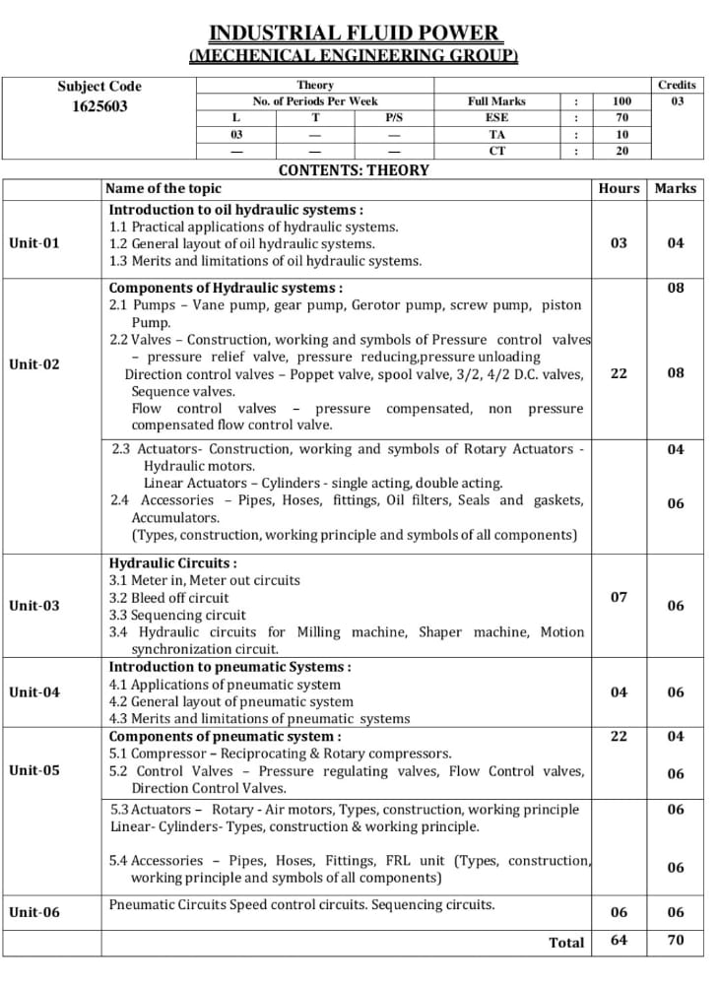

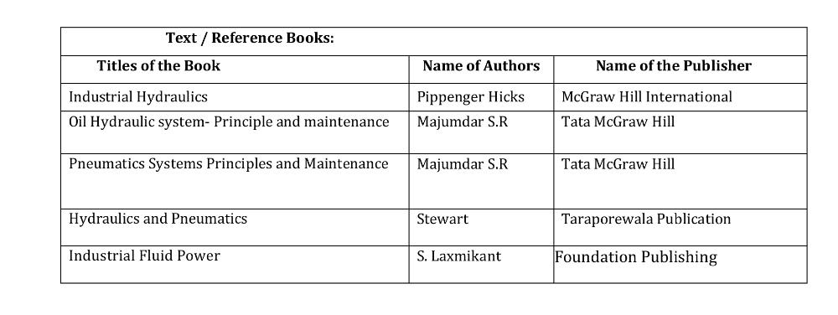

Lecture plan

Unit | Name of Topic | No. of Lecture | Date
01 | Practical applications of hydraulic systems. | Lec-1 | 15/7/22
 | General layout of oil hydraulic systems | Lec-2 | 18/7/22
 | Merits and limitations of oil hydraulic systems. | Lec-3 | 21/7/22
 | Class test-01 |  | 29/7/22
Assignment-01

Unit | Name of Topic | No. of Lecture | Date
02 | Pumps – Vane pump, gear pump, Gerotor pump, screw pump, piston Pump. | Lec-4-8 | 1/8/22
 | 2.2 Valves – Construction, working and symbols of Pressure control valves – pressure relief valve, pressure reducing,pressure unloading Direction control valves – Poppet valve, | Lec-8-12 | 4/8/22
 | spool valve, 3/2, 4/2 D.C. valves, Sequence valves. Flow control valves. | Lec-13-15 | 5/8/22
 | pressure compensated, non pressure compensated flow control valve | Lec-16-18 | 8/8/22
 | Actuators- Construction, working and symbols of Rotary Actuators - | Lec-19-20 | 11/8/22
 | Hydraulic motors. Linear Actuators – Cylinders - single acting, double acting | Lec-21 | 18/8/22
 | Accessories – Pipes, Hoses, fittings, Oil filters, Seals and gaskets | Lec-22-23 | 22/8/22
 | , Accumulators. (Types, construction, working principle and symbols of all components) | Lec-24-25 | 25/8/22
 | Class test-02 |  | 26/8/22
Assignment-02

Unit | Name of Topic | No. of Lecture | Date
03 | Meter in, Meter out circuits | Lec-26 | 1/9/22
 | Bleed off circuit | Lec-27 | 2/9/22
 | Sequencing. circuit | Lec-28 | 5/9/22
 | Hydraulic circuits for Milling machine, Shaper machine, Motion synchronization circuit | Lec-29-32 | 8/9/22
 | Class test-03 |  | 19/9/22
Assignment-03

Unit | Name of Topic | No. of Lecture | Date
04 | Applications of pneumatic system | Lec-33 | 22/9/22
 | General layout of pneumatic system | Lec-34 | 23/9/22
 | Merits and limitations of pneumatic systems | Lec-35-36 | 26/9/22
 | Class test-04 |  | 14/10/22
Assignment-04

Unit | Name of Topic | No. of Lecture | Date
05 | Compressor – Reciprocating & Rotary compressors.. | Lec-37-38 | 17/10/22
 | Control Valves – Pressure regulating valves, Flow Control valves, Direction Control Valves | Lec-39-42 | 20/10/22
 | Actuators – Rotary - Air motors, Types, construction, working principle Linear- | Lec-43-46 | 21/10/22
 | Cylinders- Types, construction & working principle. | Lec-47-51 | ………
 | Actuators – Rotary - Air motors, Types, construction, working principle Linear- Cylinders- Types, construction & working principle. | Lec-52-54 | ………
 | Accessories – Pipes, Hoses, Fittings, FRL unit (Types, construction, working principle and symbols of all components) | Lec-55-58 | ………
 | Class test-05
Assignment-05

Unit | Name of Topic | No. of Lecture | Date
06 | Pneumatic Circuits | Lec-59-60 | ………
 | Speed control circuits | Lec-61-62 | ………
 | . Sequencing circuits | Lec-63-64 | ………
 | Class test-06 |  | ………
Assignment-06

Students list
Branch-Mechanical Engg.
Roll Number | Name Of the Student
401/M/20 | FIROZAN QURESHI
402/M/20 | SAURAV KUMAR
601/M/20 | ABHAY KUMAR
603/M/20 | NISHANT KUMAR
604/M/20 | CHANDAN KUMAR
605/M/20 | KUNAL KUMAR
606/M/20 | SUNIL KUMAR

