GOVERNMENT POLYTECHNIC CHHAPRA
COURSE FILE(Lecture Plan)
AUTOMOLE AIRCONDITIONING
Faculty Name:
Prof.Mukesh Kumar
Lecturer
DEPARTMENT OF AOTOMOBILE ENGINEERING

STATE BOARD OF TECHNICAL EDUCATION
Bihar, Patna
&

CONTENTS

- Time table

- Vision of the Department

- Mission of the department

- Course Syllabus

- Reference Materials

- Student list

- 10.Lecture Plan

- Question Bank

Time table

 | 1st  ^{10:00-11:00} | 2nd  ^{1:00-12:00} | 3rd  ^{12:00-1:00} |  | 4th  ^{2:00-3:00} | 5th  ^{3:00-4:00} | 6th  ^{4:00-5:00}
MON |  |  |  | L  U  N  C  H
TUE
WED
THU
FRI
SAT

Department of Automobile Engineering

Vision
To be a centre of excellence in the field of Mechanical Engineering offering value based world class education and research producing well qualified engineers, who can contribute favorably to the technological and socio-economic development of the nation.

Mission
1. To ensure sufficient modern technological exposure to the students in order to create skilled professionals.
2. To frequently update the labs keeping in view the requirement of the current industry scenario.
3. To extend counseling and career guidance facility to the students to help them to achieve their goal.
4. To encourage faculties and staffs to pursue higher education and to do the research work.
5. To encourage faculties and staffs to participate in various seminars, conferences and workshops to keep themselves updated of the state-of-the-art technology.

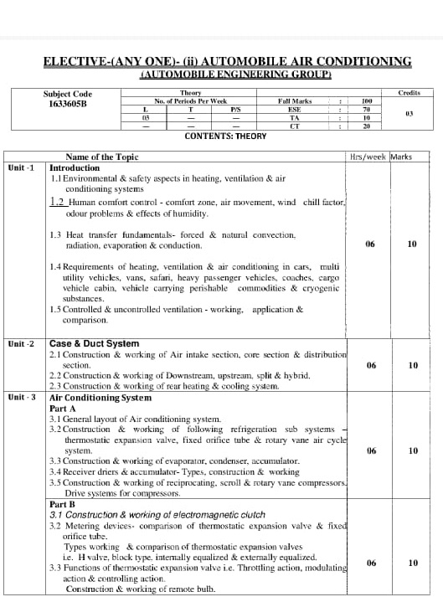

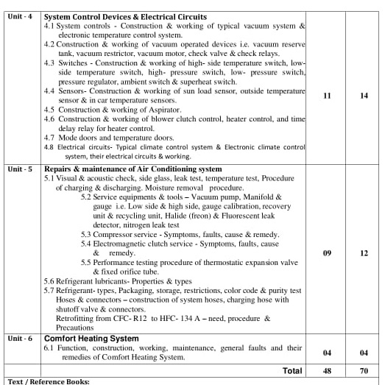

Text / Reference Books:
Automobile Air Conditioning Boyce H. Dwiggins Thomson Learning Service Manual -- Subros Company Service Manual -- Sanden Company Service Manual -- Baher Company Automotive Air conditioning & Climate control system Stevan Daley Automobile Engineering K.K Jain

Lecture plan
Unit | Name of Topic | No. of Lecture
01 | Environmental & safety aspects in heating, ventilation & air conditioning systems | Lec-1
 | Human comfort control - comfort zone, air movement, wind chill factor, odour problems & effects of humidity. | Lec-2
 | Heat transfer fundamentals- forced & natural convection, radiation, evaporation & conduction. | Lec-3
 | Requirements of heating, ventilation & air conditioning in cars, multi utility vehicles, vans, safari, heavy passenger vehicles | Lec-4
 | , coaches, cargo vehicle cabin, vehicle carrying perishable commodities & cryogenic substances | Lec-5
 | Controlled & uncontrolled ventilation - working, application & comparison. | Lec-6
 | Class test-01

Unit | Name of Topic | No. of Lecture
02 | Construction & working of Air intake section | Lec-7
 | , core section & distribution section. | Lec-8
 | Construction & working of Downstream | Lec-9
 | , upstream, split & hybrid. | Lec-10
 | Construction & working of rear heating & | Lec-11
 | cooling system | Lec-12
 | Class test-02

Unit | Name of Topic | No. of Lecture
03  PART  A | General layout of Air conditioning system. | Lec-13
 | Construction & working of following refrigeration sub systems – thermostatic expansion valve, | Lec-14
 | fixed orifice tube & rotary vane air cycle system | Lec-15
 | Construction & working of evaporator, condenser, accumulator. | Lec-16
 | Receiver driers & accumulator- Types, construction & working | Lec-17
 | Construction & working of reciprocating, scroll & rotary vane compressors. Drive systems for compressors. | Lec-18
 | Class test-03

Unit | Name of Topic | No. of Lecture
03  PART  B | Construction & working of electromagnetic clutch | Lec-19
 | Metering devices- comparison of thermostatic expansion valve & fixed orifice tube | Lec-20
 | Types working & comparison of thermostatic expansion valves i.e. H valve, block type, internally equalized & externally equalized | Lec-21
 | Functions of thermostatic expansion valve | Lec-22
 | Throttling action, modulating action | Lec-23
 | & controlling action. Construction & working of remote bulb compressors. | Lec-24
 | Class test-03

Unit | Name of Topic | No. of Lecture
04 | System controls - Construction & working of typical vacuum system & electronic temperature control system.. | Lec-25
 | Construction & working of vacuum operated devices i.e. vacuum reserve tank, | Lec-26
 | vacuum restrictor, vacuum motor, check valve & check relays | Lec-27
 | Switches - Construction & working of high- side temperature switch, lowside temperature switch, high- pressure switch | Lec-28
 | , low- pressure switch, pressure regulator, ambient switch & superheat switch. | Lec-29
 | Sensors- Construction & working of sun load sensor, outside temperature sensor & in car temperature sensors | Lec-30
 | Construction & working of Aspirator | Lec-31
 | Construction & working of blower clutch control, heater control, and time delay relay for heater control | Lec-32
 | Mode doors and temperature doors. | Lec-33
 | Electrical circuits- Typical climate control system | Lec-34
 | Electronic climate control system, their electrical circuits & working, | Lec-35
 | Class test-04

Unit | Name of Topic | No. of Lecture
05 | Visual & acoustic check, side glass, leak test, temperature test, Procedure of charging & discharging. Moisture removal procedure. | Lec-36
 | Service equipments & tools – Vacuum pump, Manifold & | Lec-37
 | gauge Low side & high side, gauge calibration, recovery unit & recycling unit, Halide (freon) & Fluorescent leak detector, nitrogen leak test. | Lec-38
 | Compressor service - Symptoms, faults, cause & remedy. | Lec-39
 | Electromagnetic clutch service - Symptoms, faults, cause & remedy. | Lec-40
 | Performance testing procedure of thermostatic expansion valve & fixed orifice tube. | Lec-41
 | Refrigerant lubricants- Properties & types | Lec-42
 | Refrigerant- types, Packaging, storage, restrictions, color code & purity test Hoses & connectors – | Lec-43
 | construction of system hoses, charging hose with shutoff valve & connectors. Retrofitting from C | Lec-44
 | Class test-05

Unit | Name of Topic | No. of Lecture
06 | Function, construction Comfort Heating System | Lec-45
 | working, maintenance Comfort Heating System | Lec-46
 | , general faults of comfort Heating System | Lec-47
 | remedies of Comfort Heating System | Lec-48
 | Class test-06

Student list

Roll Number | Name Of the Student
401/E/20 | SUNNY KUMAR
402/E/20 | VIVEK RAJ
601/E/20 | RANJEET KR. RAM
602/E/20 | RAJEEV KUMAR
603/E/20 | NITESH KUMAR LAL
604/E/20 | GULFAN ALAM
605/E/20 | ASHISH RAJ

